Accountable to: Learning & Evaluation Manager

Responsible for: None

Location: Based in Pitfield Street office, with some home working

| An introduction to London Youth
We are London Youth. A charity on a mission to improve the lives of young people in London, challenging them to become the best they can. Young people need opportunities outside school to have fun with their friends, to learn new skills, to make positive change in their communities and to shape the city they live in.
In our last full operational year, we worked with over 27,000 young people through our sports development, employability, youth action and involvement, arts and outdoor education programmes. Our work gives young people access to opportunities they might not otherwise have had.
Throughout our history, community youth organisations have provided a constant lifeline and a vital safe space outside the family and formal education, where young people can develop confidence, resilience and skills.
Our vision is that all young Londoners grow up healthy, able to express themselves, navigate a fulfilling career and make a positive contribution in their communities.
Our mission is to support and challenge young people to become the best they can be; developing their confidence, resilience and relationship skills.
We do this with, and through, our network of community youth organisations and at our two residential centres. We look to work with all young people, focusing particularly on those who wouldn’t otherwise have access to the kind of opportunities we offer.
Because good youth work works.

| London Youth’s 20-25 Strategy
London Youth is in Year two of the 20-25 Strategy, the key objectives of which are to:

1. Deliver Opportunity: we will deliver opportunity at scale and breadth for young people. We will get better at hearing and understanding the needs of young people and members and more adaptive at turning what we hear into practical applications. We will emphasise the distinctive way our programmes also build capacity.

2. Drive Impact: we will improve our responsiveness and customer service, leveraging digital technology. We will better connect members to support within London Youth plus expertise and support beyond. We will increase our understanding of our impact for members and use this to improve our work.

3. Demand Change: we will be a bold advocate for change, amplifying the voices of young people and youth workers. We will be unapologetic about voicing the needs of London and putting the needs of young Londoners first. We will identify points in the system where we can get best leverage for change and put sustained focus there.

We will do this within the context of a sustainable business model.

As the key pan-London network of youth organisations we have a unique opportunity to respond to city-wide issues. Within the strategy there are key cross-cutting themes where we believe we can make an important contribution:

• Reducing serious violence affecting young people
• Increasing the support available to young people in outer London boroughs

Mental health and employability are also prominent issues for young Londoners that have been significantly exacerbated by the pandemic, and we expect to be providing greater support to members and their young people in these areas.

| Our principles

Throughout our work we strive to act in line with our four simple principles:
• Honesty – about what works (and what doesn’t) and we learn from our mistakes
• Collaboration – with each other, young people, our members, and the world beyond
• Improvement – committed to continual improvement
• Fun – because we think people learn best when enjoying themselves

We have young people involved in London Youth’s formal governance systems and have a flourishing youth board. We actively promote wider youth involvement and amplifying youth voice.

| Our commitment to anti-racism

In July 2020, we issued a statement committing to become an anti-racist organisation and to actively tackle racism. Since then, London Youth has worked with our staff and trustees to understand first the issues within our organisation, collaboratively developing a Theory of Change to define our areas of focus, approach and plan of action moving forward.

We have a Race Equality Action Stakeholder Group which is chaired by a London Youth member and trustee. This group includes representatives from across the organisation and oversees the implementation of our Race Equality Action Plan. At the heart of youth work is the drive to level the playing field for all young Londoners to succeed, regardless of their backgrounds. Over two thirds of the young people we work with are from racialised communities and we know that without the opportunities which youth organisations provide, there would be limited experiences open to them.

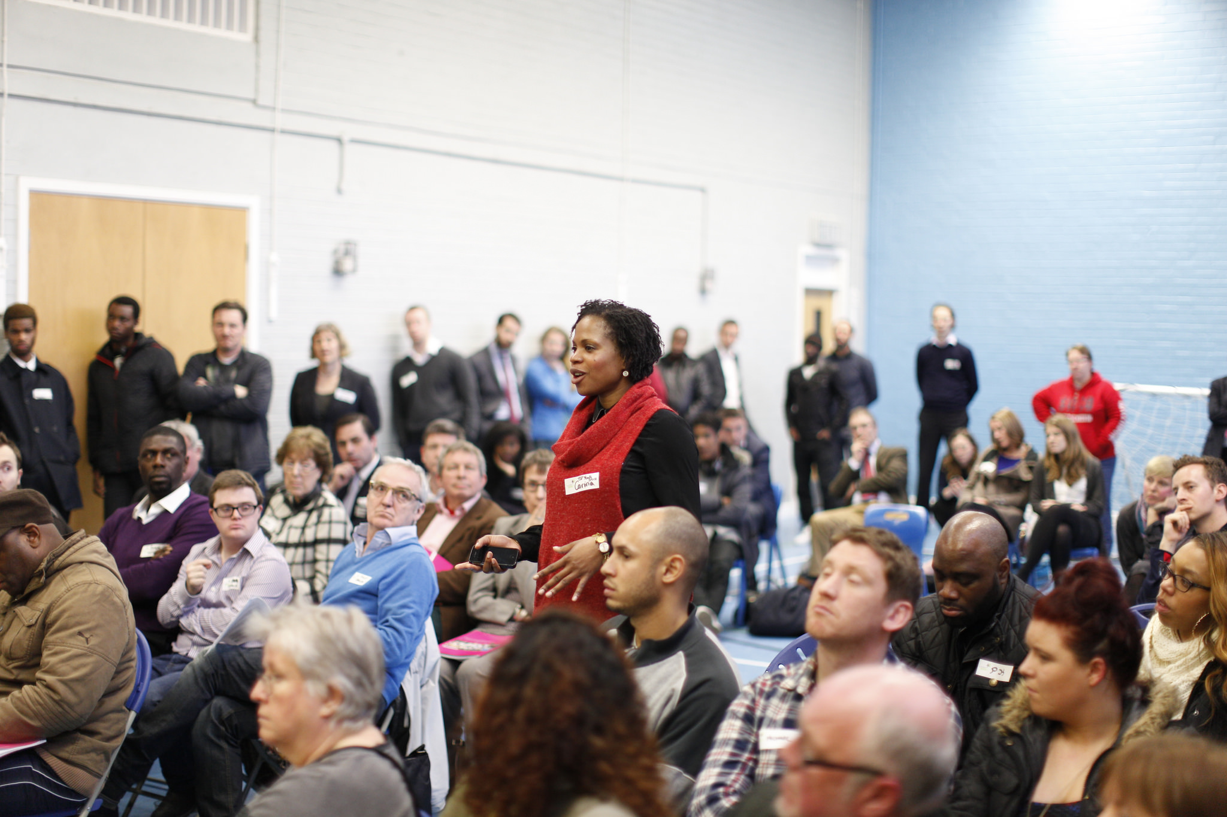
| Learning at London Youth

London Youth committed to becoming a learning organisation over a decade ago and since then we have been collecting, analysing and using data and information and turn them into usable learning insights. Internally, we developed Theories of Change and monitoring, evaluation & learning (MEL) frameworks for most of our delivery elements, focused on reach, delivery and impact. We use databases for our data and PowerBI to visualise it to enable better use. Our teams implement Learning to Action sessions to reflect on and to learn from what they do. We are passionate about using the data we gather from our three key target groups to inform our work: young people, youth work practitioners and youth organisations – our members.

Externally, we’ve been collecting data about our youth organisation members in order to inform our membership offer to them and gain a better understanding of the youth sector in London. We are looking to expand our external outlook, commissioning and collaborating with partners on research. We also support London’s youth organisations’ MEL journey through training and the Regional Impact Network.

The Learning team is envisioned as the hub of corporate knowledge, ensuring everyone can use data, information and learning about our processes, models and impact. It holds the oversight of all of London Youth’s MEL work which is implemented by our delivery teams directly or with external evaluators and consultants.

The Learning team is a part of the Engagement Directorate, which is comprised of the Membership and Sector Development, Communications and Policy, and Digital teams.

| The Role

We are looking for an individual with belief and passion in London Youth’s mission, who will ensure quality and efficiency of internal reporting, analyse internal and external data and support its use to inform decision making. The role is focused on ‘doing’ but will also include some elements of ‘advising’ to our teams on data collection, analysis, reporting and learning, and to other stakeholders on how to use our membership data. Someone who loves the technical elements of MEL work but is also a people’s person would be ideal.

Current priorities include reviewing internal reporting processes, maintaining and developing monitoring dashboards; supporting our delivery team to standardise data collection and recording processes via databases such as Upshot whilst advising on MEL tools; analysing membership data for intelligence reports, and; supporting our members with their own learning journeys through the networks and training we convene.

| Role Description

Main duties of the role | % of role
Improvement and oversight of processes and systems  - Review and map our corporate (internal) quarterly and annual reporting process about London Youth’s reach, delivery and impact. Support managers to produce reports and contribute to them.  - Identify improvements to current data management systems and processes, and work with Learning & Evaluation Manager to ensure these are as efficient and effective as possible.  - Develop data quality assurance processes and guidance, and deliver training to delivery staff. | 40%
Analyses and visualization of data for learning  - Hold responsibility for internal reporting dashboards, the Programmes Directorate existing PowerBI data reports and other future reports and dashboards, primarily focused on young people participating in our activities.  - Work alongside colleagues who hold responsibility for other datasets and dashboards to support the identification of trends and insights, leading to learning.  - Conduct analysis of quantitative and qualitative data as needed | 40%
Intelligence reports support  - Work closely with the Learning & Evaluation Manager and others to support the development of external reports, including to:  - Conduct data collection and analysis  - Commission external researchers  - Bring reports to publication (eg design and printing) | 10%
MEL support  - Support London Youth managers and delivery staff to develop and implement robust MEL plans.  - Support London Youth managers and delivery staff to understand and act on learning data  - Convene and coordinate the London Regional Impact Network  - Lead on the development of member engagement report templates | 10%

| Person Specification

Skills, experience and knowledge | Essential (E) Desirable (D)
Demonstrable understanding of evaluation or research principles, methods and tools | E
Proven track record of using a range of research and evaluation methods | E
Highly competent at quantitative and qualitative data analysis | E
Ability to communicate technical information in an engaging and accessible way to various audiences, including those with less data experience | E
Strong IT skills, highly competent in Excel | E
Experience of preparing written reports or papers | D
Experience of using data management and CRM systems (ideally Salesforce and Upshot) | D
Qualifications
We want to see evidence of data analysis or research. This could be through experience and/or through a degree that had this as a significant component | E
Personal attributes
Passionate about and committed to improving the lives of young Londoners | E
Commitment to anti-racism and equal opportunities, promoting London  Youth’s principles amongst colleagues, our members and stakeholders | E
Excellent attention to detail and organisational skills | E
Strong oral and written communication skills | E
Willingness to learn new skills and apply them | E
Ability to work autonomously and on your own initiative | E
Ability to work as part of a team with a strong collaborative approach | E
Absolute discretion and ability to maintain confidentiality | E
Ability to work in a changing and flexible organisation | E

Terms and Conditions
Salary: £28,675 plus contributory pension scheme

Location: Based in Pitfield Street office, with some home working

Hours: 37.5 hours per week – NB while this post is office based, there will be a need to work occasional evenings in line with our members’ needs, as youth organisations mostly operate outside of the school day

Leave: 31 days (28 annual leave and 3 office closure days) p.a. plus 8 bank holidays

Term: Ongoing

