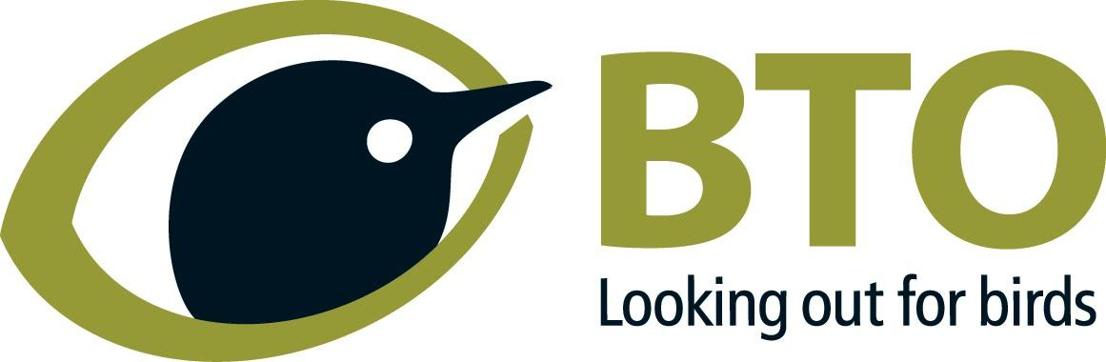

Engagement Coordinator (Northern Ireland)
Based remotely in Northern Ireland in the first instance
Full time, Permanent
£28,644 per annum + 11% employer pension contribution

We are seeking an enthusiastic staff member and excellent communicator, with a passion for birds,
for people and for volunteer-based surveys, to be the public face working with our supporters in
Northern Ireland (NI).
This is a permanent, full-time role based in NI. The postholder will work from home in the first
instance (but we are currently exploring possibilities to establish a small office in NI in due course).
The postholder will join our small but growing team at BTO NI, and be responsible for: supporting
and growing our network of volunteers to expand coverage of our long-term monitoring schemes
and surveys; providing regular training opportunities for existing and prospective volunteers; and
communication and profile-raising work in NI. They will be line managed by Ben Darvill, BTO’s Head
of Engagement for Country Operations, and supported strategically by Ben and by Chris Wernham,
BTO’s Associate Director for Country Operations (both based in Stirling, Scotland). The postholder
will work alongside our two existing staff members based in NI – Research Ecologist, Hala el Haddad
and Community (Ripple) Project Officer, Sorrel Lyall, and our volunteer ambassadors, including our
Youth Rep in NI. They will also work alongside Katherine Booth Jones, Senior Research Ecologist
(based in Scotland), who leads on our science work in NI.

Please note that this post is funded externally to BTO and appointment will be subject to grant funding confirmation (which is currently expected by the end of March). You do not need to do anything, and we will continue our recruitment process as normal, but no formal offer of employment will be made until we have received confirmation of funding.

You can read the full role description by clicking on the role description under 'supporting documents' in the job details on our careers page. Please contact us if you are not sure if you meet all the criteria for the role and would like to discuss the role in more detail.

WHAT DOES BTO DO?
BTO harnesses the skills and passion of birdwatchers to advance our understanding of ornithology and produce impartial science, communicated so that it can be of benefit to everyone.

OUR GOALS
BTO increases knowledge of birds and other wildlife, and their relationships with the environment and people, by:
- Enabling more people to learn about birds and science and grow through participation in environmental discovery.
- Delivering impartial, impactful and relevant science.
- Inspiring and empowering people with an understanding of birds and the importance of knowledge.

OUR FOUNDATIONS AND VALUES
The success of BTO is based on firm foundations that include: motivated and skilled staff and volunteers; a strong reputation; a robust business model and effective governance systems and processes.
We are:
- Inclusive and supportive
- Impartial
- Passionate
- Collaborative and open to new ideas

WHAT WE OFFER
- £28,644 per annum
- Annual leave entitlement on starting is 25 days plus bank holidays (pro rata if part time).
- Life assurance (four times salary)
- 11% employer pension contribution
- Employee Assistance Programme offering help and advice to staff and their families on matters related to bereavement, wellbeing, finances, relationships, family and more. This includes a number of free counselling sessions if they are needed.
- Retail discounts
- Cycle to work scheme- spread the cost of purchasing a new bike and save money
- Discounts on BTO books
- Flexible working- A combination of home and office working and flexible start and finish times.
- Free eye tests and a contribution of £49 towards prescription glasses for VDU use only.
- Free car parking
- Effective job evaluation policy that recognises where staff increase their level of responsibility over time
- Coaching and mentoring scheme
- Staff groups and forums- First Aiders and mental health first aiders, Coaching and mentoring, Diversity working, Sustainability and Natural Working, and our staff group, creating a positive and welcoming culture to work in.
- No matter what role you have at BTO, everyone is making a difference by contributing to the delivery of impactful science.
- Commitment to creating an inclusive environment
- Commitment to sustainability

Closing date for receipt of applications is 12:00 noon on Wednesday 29th March and Interviews are expected to be held remotely on Wednesday 19th April.

If you have any questions, please contact recruitment@bto.org

If you have a disability or long-term illness that otherwise prevents you from meeting any of the essential criteria, please contact us to discuss whether a reasonable adjustment could be made.
As users of the disability confident scheme, we guarantee to interview all disabled applicants who meet the essential criteria for the vacancy.

We recognise that candidates from minority ethnic groups are under-represented in our organisation, and that there are often additional barriers present for people from these groups when applying for roles in the charity sector and beyond. We are committed to taking positive action to expand the diversity of our staff team, and if you meet the essential criteria for a role and are from a minority ethnic background, you'll be guaranteed a first stage interview.

Charity No. 216652 (E&W); SC039193 (Scotland)
